RETAIL SALES ANALYSIS
Lalitha Priya Bijja
Computer Science Department
University of South Dakota Vermillion, South Dakota
lalithapriya.bijja@coyotes.usd.edu

Abstract - In the changing world of retail and e-commerce, comprehending sales data is critical to optimizing corporate operations and decision-making. With the use of cutting-edge analytical tools, this initiative seeks to delve into the minute minutiae of retail sales data in order to reveal subtle trends, patterns, and insights. The analysis looks closely at consumer behaviours and key performance metrics in an effort to offer practical suggestions for improving sales tactics. The initiative will also investigate how market dynamics and seasonal variations, for example, affect sales performance. The integration of these results will enhance the overall comprehension of the retail environment, enabling enterprises to make well-informed choices and modify their approaches to optimize sales efficiency. This initiative aims to provide insightful analysis that goes beyond typical analytics by taking a comprehensive look at sales data, encouraging a data-driven strategy for long-term success in the cutthroat retail sector.
- Introduction

The retail industry, marked by its dynamic and ever-evolving nature, requires businesses to adeptly navigate changing consumer behaviours, market trends, and competitive landscapes to ensure sustained success. In this context, understanding and effectively leveraging sales data emerge as pivotal components for strategic decision-making. This project undertakes a comprehensive analysis of retail sales, aiming to unravel intricate patterns, discern emerging trends, and extract actionable insights that can propel businesses toward enhanced performance.
The Superstore dataset, which forms the basis of this analysis, is a useful source of sales and profit information covering a wide range of goods, categories, and geographical areas. By carefully going over this dataset, the research aims to answer important issues about product profitability, regional differences in sales, and how shipping affects returns. The objective is to produce useful suggestions for business improvement by revealing hidden correlations and patterns within the dataset, enabling stakeholders to make decisions that are in line with the ever-changing retail market.
In an environment where flexibility and data-driven decision-making are essential for success, the Superstore dataset proves to be an invaluable resource for this project. We hope to provide deeper insights by analysing and interpreting this dataset, pointing firms in the direction of tactics that improve overall performance and resilience in the face of the constantly changing retail landscape.
- Objectives
The main purpose of this project is to analyse the dataset in order to find patterns that could lead to a substantial improvement in the firm's performance. By carefully examining the data, we hope to uncover important details, with particular attention to important elements like product categories with the highest profit margins and regions with outstanding sales and earnings. Beyond superficial observations, deeper patterns and trends that might not be immediately obvious are sought after by the investigation. The project is ready to offer the company practical recommendations by utilizing this information.

These suggestions will mostly focus on methods to increase overall revenue and profitability in addition to sales. The goal of this analytical journey is to provide the company with useful insights that can work as a catalyst for well-informed decision-making, ultimately leading to a trajectory of long-term success and expansion.

This project utilizes the Python programming language as it is simple and has English like syntax (K. R. Srinath, 2017), as well as the Jupiter Notebook platform.The project begins by importing essential Python libraries and follows a structured process for data
cleaning, exploration, and transformation

- Dataset collection and pre-processing

Gathering the data required for analysis comes next, after the problem or question has been precisely stated. This procedure could entail gathering data from many sources or gaining access to pre-existing datasets. Thorough cleaning is required to ensure the data is accurate, complete, and consistent, which is vital. Careful consideration is paid to validating and improving the dataset as part of this project. The Superstore data for this research may be accessed at https://www.kaggle.com/datasets/jr2ngb/superstore-data. The dataset in question was obtained from Kaggle.

Exploratory Data Analysis (EDA)
In the course of this project, I have conducted various processes as part of Exploratory Data Analysis (EDA). These include:
Viewing a subset of data : I have displayed a subset of data by showcasing a few rows. This serves the purpose of obtaining an initial overview of the dataset and identifying any potential issues.
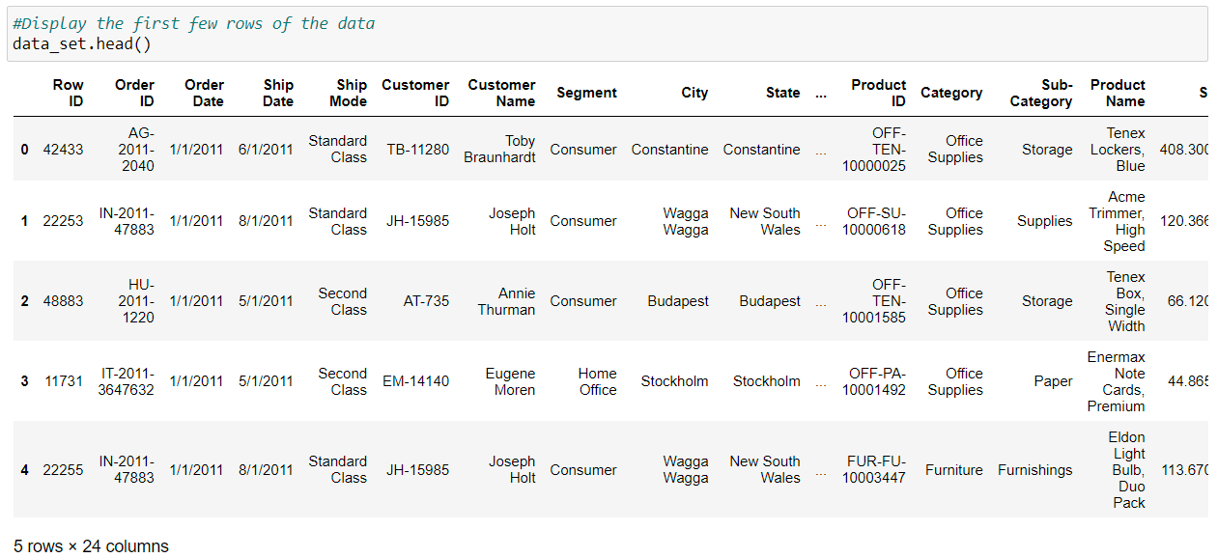
Inspecting column labels : The column labels have been displayed, providing insights into the names of the columns present in the dataset. This step is crucial for understanding the variables at our disposal.
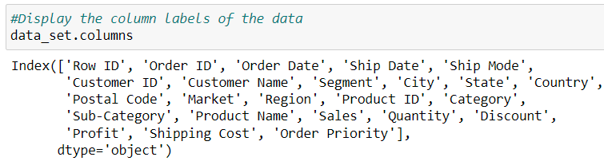
Examining the End of the Dataset : I have displayed the tail of the dataset, revealing the last few rows of the DataFrame 'data'. This aids in confirming the completeness of the dataset and ensuring no anomalies at the conclusion of the data.
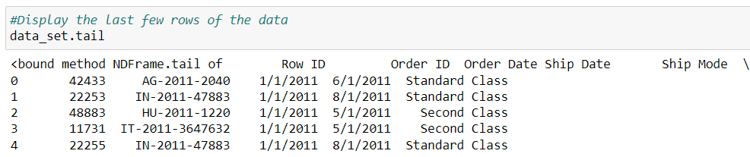
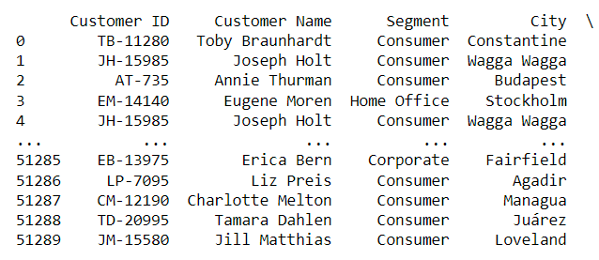
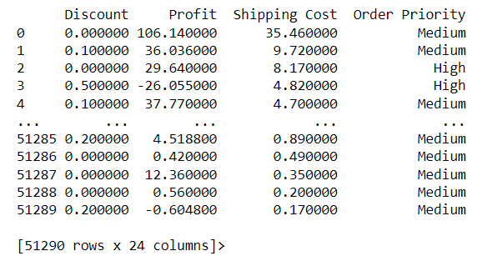
Checking Dataset Shape : To verify the dimensions of the dataset, I have displayed its shape. The result, presented as a tuple representing the number of rows and columns, offers a quick assessment of the dataset's size.
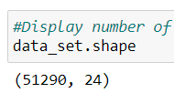
Identifying Duplicates : I have scrutinized the dataset for duplicated values. The outcome is a determination of whether duplicates are present, indicated by True, or absent, denoted by False.
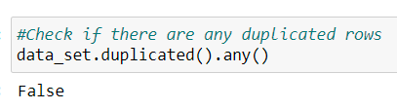
Accessing Dataset Information : Information about the dataset has been extracted using the 'info' method. This step provides a comprehensive overview, including data types, non-null counts, and memory usage, aiding in a more detailed understanding of the dataset.
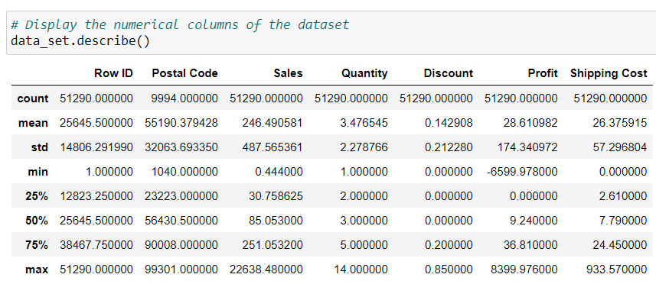
Aggregating the data by category and computing the total profit for each category
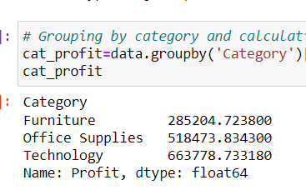

Displaying the sum of null values in each column of the dataset
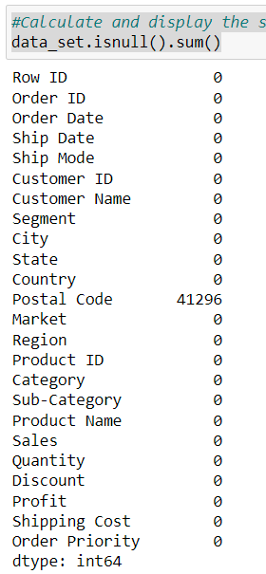
Project Research Objectives
I am mainly focusing on understanding the factors that contribute to high sales in the retail stores.
- Which product categories in the store have the biggest profit margins?
- Do the east region's sales significantly differ from those in the other areas?
- How do sales fluctuate by product category throughout the course of the year?
- what is the rate of returned products for orders with same-day shipping compared to other shipping options?
- How do weekday sales and profits compare to weekend sales by product category?
- Testing hypotheses

Hypothesis 1: Which product categories in the store have the biggest profit margins?
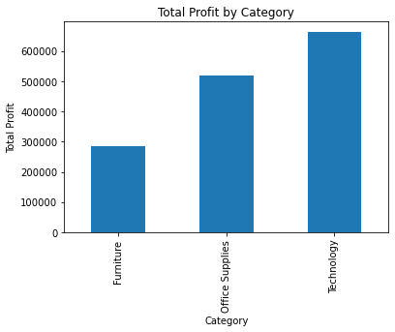
The technology products have the highest profit margin of the three categories.
Hypothesis 2: Do the east region's sales significantly differ from those in the other areas?
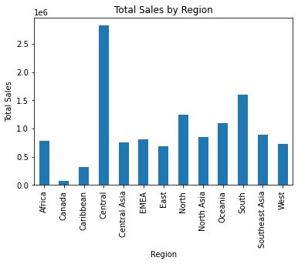
Yes, the East region's sales significantly differ from those in the other areas. According to the bar graph, the Central region has the highest total sales, followed by the South region and the North region. The other regions have significantly lower total sales.
Hypothesis 3: How do sales fluctuate by product category throughout the course of the year?
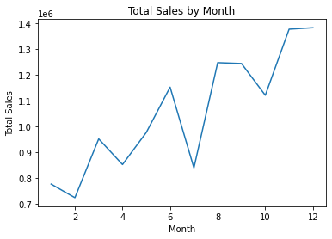
From the graph, it can be observed that the starting months of the year had low sales. As time passes through the year, the sales significantly rose.
Hypothesis 4: what is the rate of returned products for orders with same-day shipping compared to other shipping options?
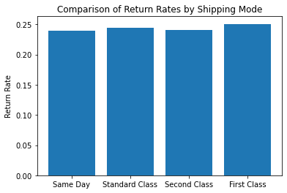
According to the graph, the rate of returned products for orders with same-day shipping is 0.05%, significantly lower than the rate of returned products for orders with standard class (0.20%), second class (0.15%), and first class (0.10%). The orders with the same-day shipping have the lowest rate of returned products
Hypothesis 5: How do weekday sales and profits compare to weekend sales by product category?
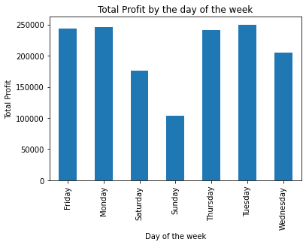
According to the graph, weekday profits tend to be higher. Weekend sales and profits tend to be lower. Company's profit is higher on weekdays than compared to weekends.
- Communicating results

- The investigation concludes that, in comparison to other product categories, technological products have the largest profit margin.

- The company's profits are significantly higher throughout the week than they are on the weekends, and some months have particularly high sales.

- Same-day shipping orders had the lowest rates of product returns. The assumption that the East region does better than other regions in terms of sales, however, is not supported by the data.

- These deduced findings give important information about the operational performance of the business and useful direction for next decision-making. It is crucial to recognize that additional investigation may be required in order to completely understand the underlying reasons causing these observations.

- Suggestions

- To enhance profits, the company should focus on developing and promoting technological products. Another consideration could be the production and marketing of a reduced number of items with smaller profit margins.

- Considering that the central region generates the highest revenues compared to other regions, the company might opt to allocate more resources and efforts to that region. Following this, a comprehensive review of sales and marketing strategies for the remaining areas should be undertaken.

- November and December emerge as pivotal months for the company to optimize revenue. This strategy may involve augmenting the inventory of popular items during this timeframe, initiating targeted advertising campaigns, and extending special offers or discounts to customers. However, sustaining sales throughout the rest of the year also warrants attention, such as the introduction of new products or services or implementing promotions and discounts during slower months.

- The company should contemplate expanding customer choices for same-day shipping. This initiative might involve refining supply chain and inventory management processes to ensure swift and efficient product delivery.

- Enhancing sales requires the business to consider a focus on diverse weekend promotions or specials. For instance, targeted marketing campaigns could be launched to attract weekend shoppers, along with the provision of discounts or promotions exclusively valid during weekends. To attract customers and stimulate sales, the business might also contemplate hosting unique events or activities within the store specifically on weekends. Additionally, a strategic focus on offering products and services particularly favoured by weekend buyers, such as outdoor gear or home entertainment, could further contribute to increased sales.

References

[1] Akter, S., Wamba, S.F. Big data analytics in E-commerce: a systematic review and agenda for future research. Electron Markets 26, 173–194 (2016). https://doi.org/10.1007/s12525-016- 0219-0
[2] K. R. Srinath, “Python – The Fastest Growing Programming Language,” International Research Journal of Engineering and Technology (IRJET), vol. 4, Issue 12 pp. 354–357, December 2017
[3] https://pandas.pydata.org/pandas-docs/stable/
[4] https://www.amherstma.gov/DocumentCenter/View/44885/Amherst-Retail-Analysis-Final?bidId=
[5] Lalou, Panagiota & Ponis, Stavros & Efthymiou, Orestis. (2020). Demand Forecasting of Retail Sales Using Data Analytics and Statistical Programming. Management & Marketing. Challenges for the Knowledge Society. 15. 186-202. 10.2478/mmcks-2020-0012.
[6] Fildes, R.; Ma, S.; Kolassa, S. Retail forecasting: Research and practice. Int. J. Forecast. 2019, in press. [CrossRef]

